|  |  |
| --- | --- |
| 1.jpg  How to Participate in a REverse Auction  © 2019 AgileApt Solutions P Ltd. | Abstract  A Step by Step Approach on How to Participate in a Reverse Auction Bid invited by your customer  Procur[E]ngine Team  Issue Date: January 1st, 2019 |

***Prerequisites***

1. Please ensure you are using latest version of Google Chrome, Internet Explorer, Mozilla Firefox or Safari.

**(Recommended: Google Chrome latest version). You may Download the latest version of Google Chrome by visiting** [**https://www.google.co.in/intl/en/chrome**](https://www.google.co.in/intl/en/chrome)

2. Please check your internet connectivity. Good internet connection is required for best user experience.

3. Visit <http://procurengine.com/xxx> to access our sourcing portal. We recommend visiting portal with provided user id and password in advance to read terms & conditions, documents (if applicable) and fill related prerequisite information.

**Start Participation Reverse Auction Bid**

**Step 1:**

You would have received emails on your 2 registered email ids from the customer. One is the main email id, which is used for running the reverse auction and second one is for notifications only.

The person who is registered to run the Reverse Auction will get an email alert, which will have **complete details of the reverse auction, with login id, password** and other details.

The email will look like as under:

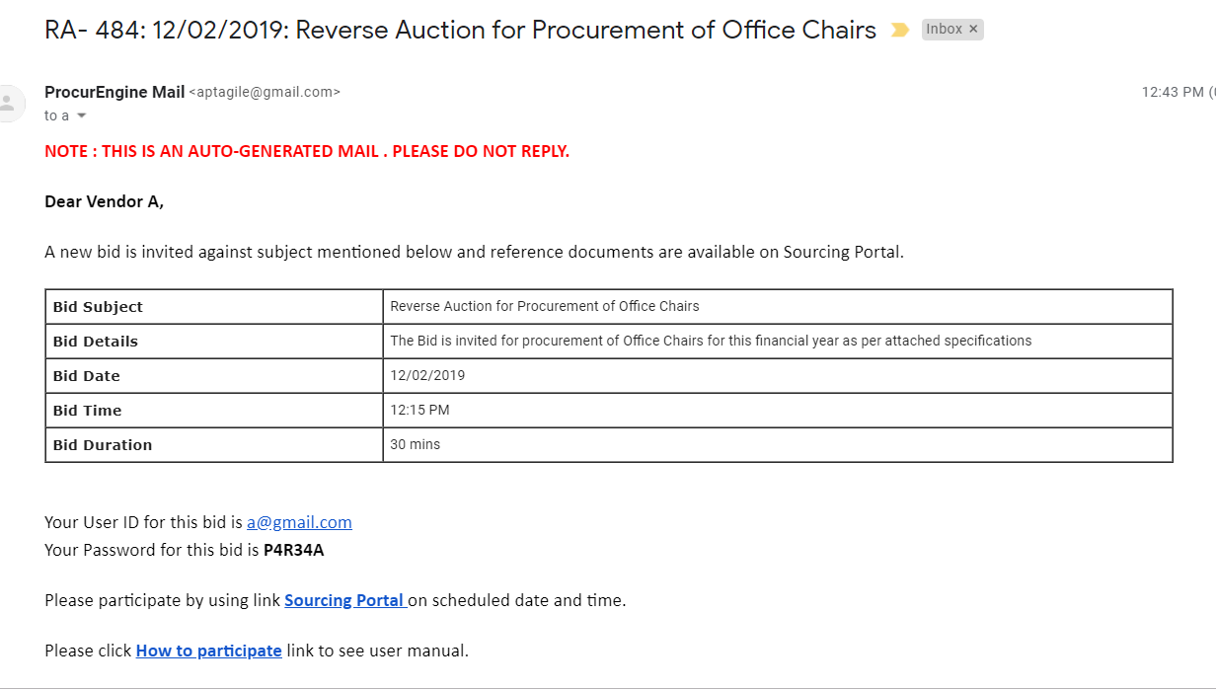

The alternative email will get **a notification only** of the event as under:

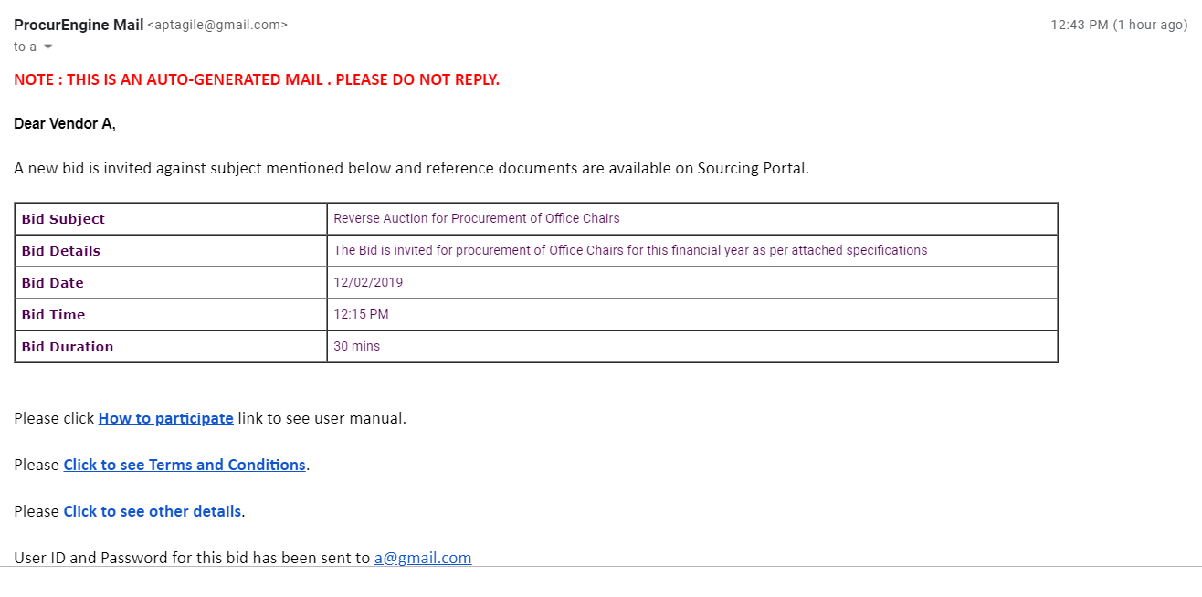

This email alert **will not get username and password** and will only give email id on which these details have been sent.

**Step 2:**

Please login using the credentials given on the email sent to the main registered id. The following home screen will appear (note: Home Screen may vary based on the customization for your customer):

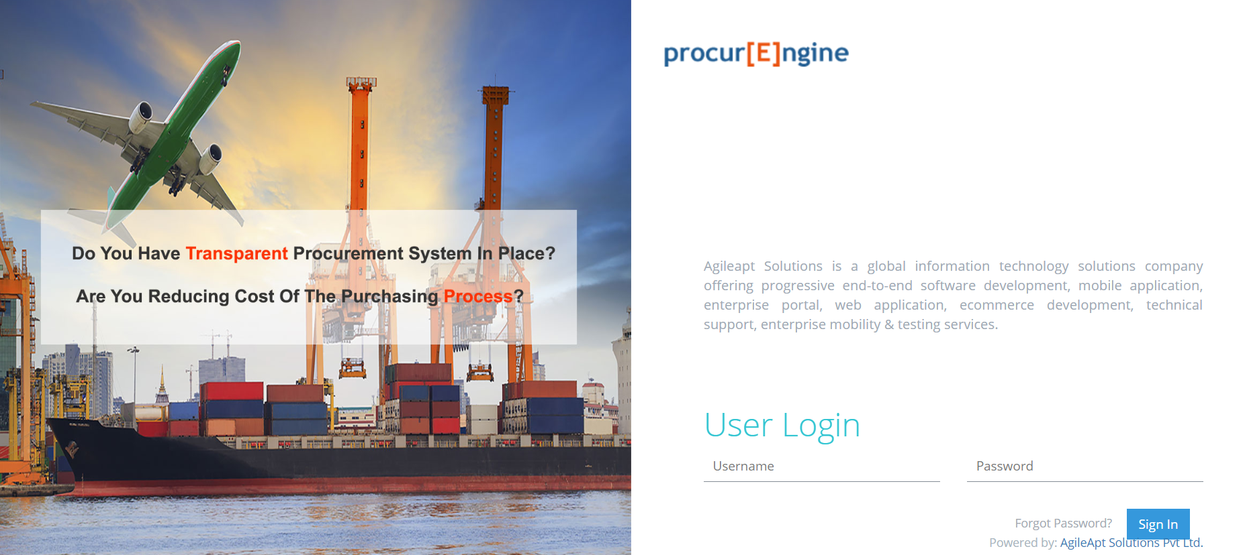

**Step 3:**

Upon logging, you will be directed to accept “General Terms and Conditions” of the procurement policies of the customer.

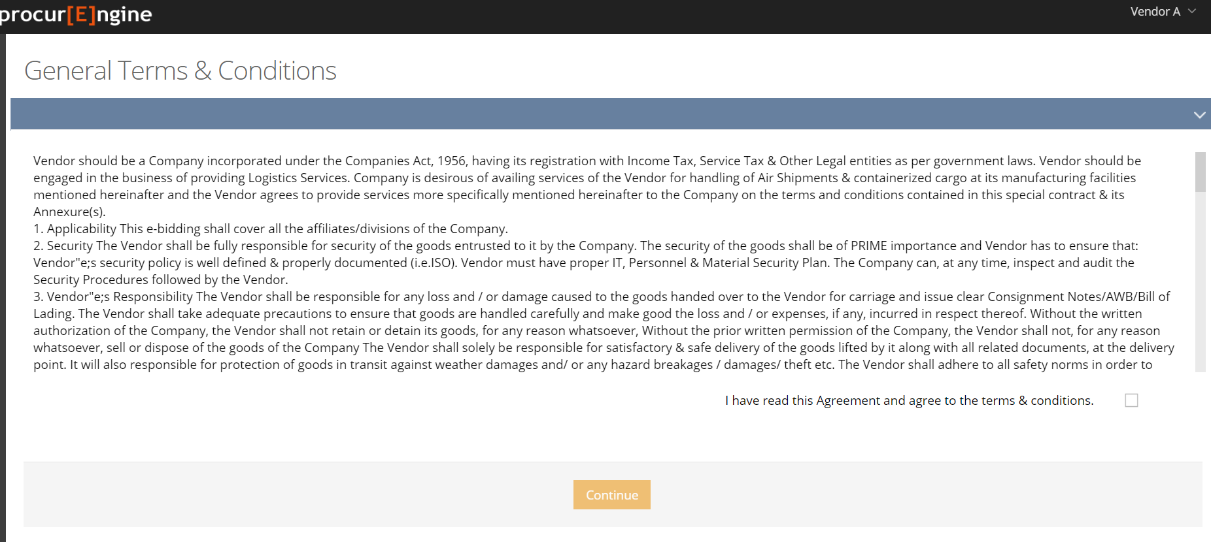

You please study the same and give your acceptance and press **Continue.**

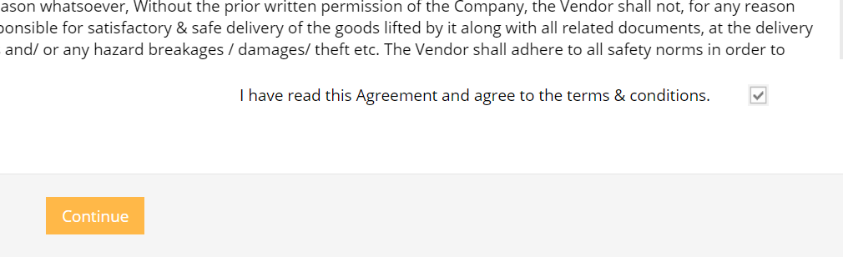

**Step 4:**

It is important that you log in well in advance of the specified time of the reverse auction. This will enable you getting complete details of the auction well in advance for better participation.

Upon logging, your home screen dash board will appear as under:

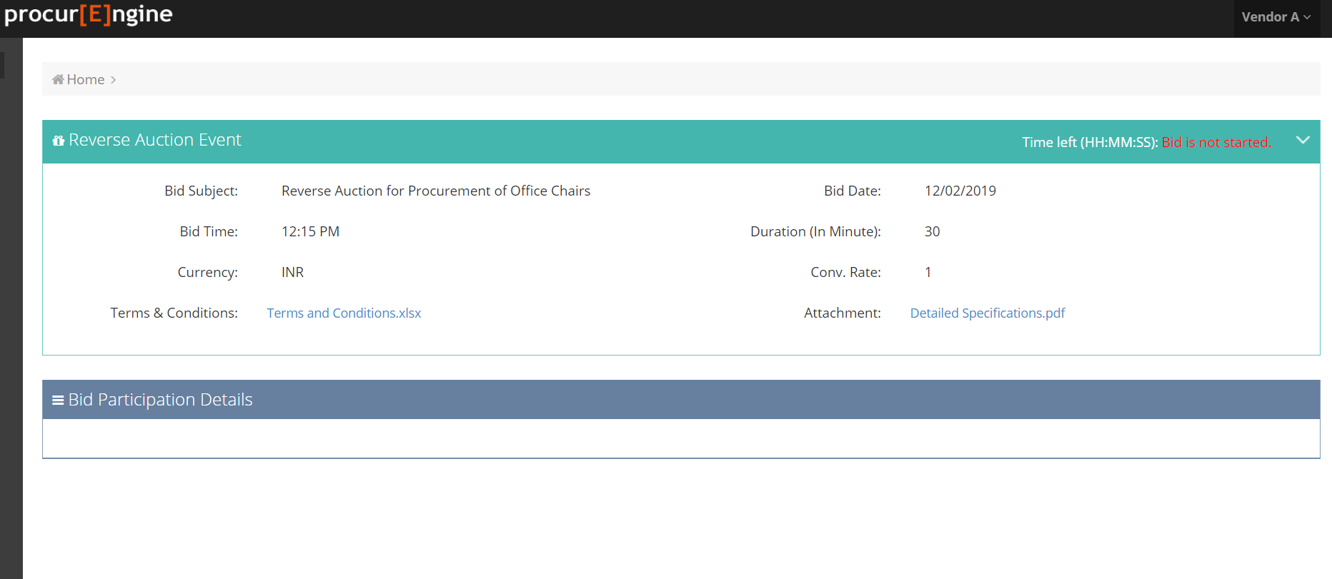

**Step 5:**

Please download and study the attachments given in the bid. One attachment gives the complete **terms and conditions** of bid. The customer may have attached (optional) other details as may be required for the bid like product specifications etc.

Please carefully study the attachments.

**Step 6:**

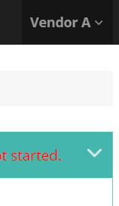

You may also check if your details are correctly filled in the at your customer portal by clicking right hand top panel

The following screen will appear. You can update your mobile number yourself. For rest of the corrections, please contact your customer RA administrator.

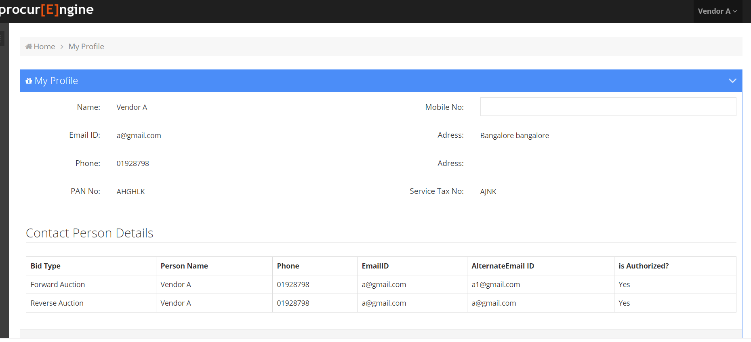

**Step 7:**

Please login at the specified time of the bid. In case the bid is not started, you will be indicated that.

**Please refresh your screen** upon start of the time. The following screen will appear upon start of bidding:

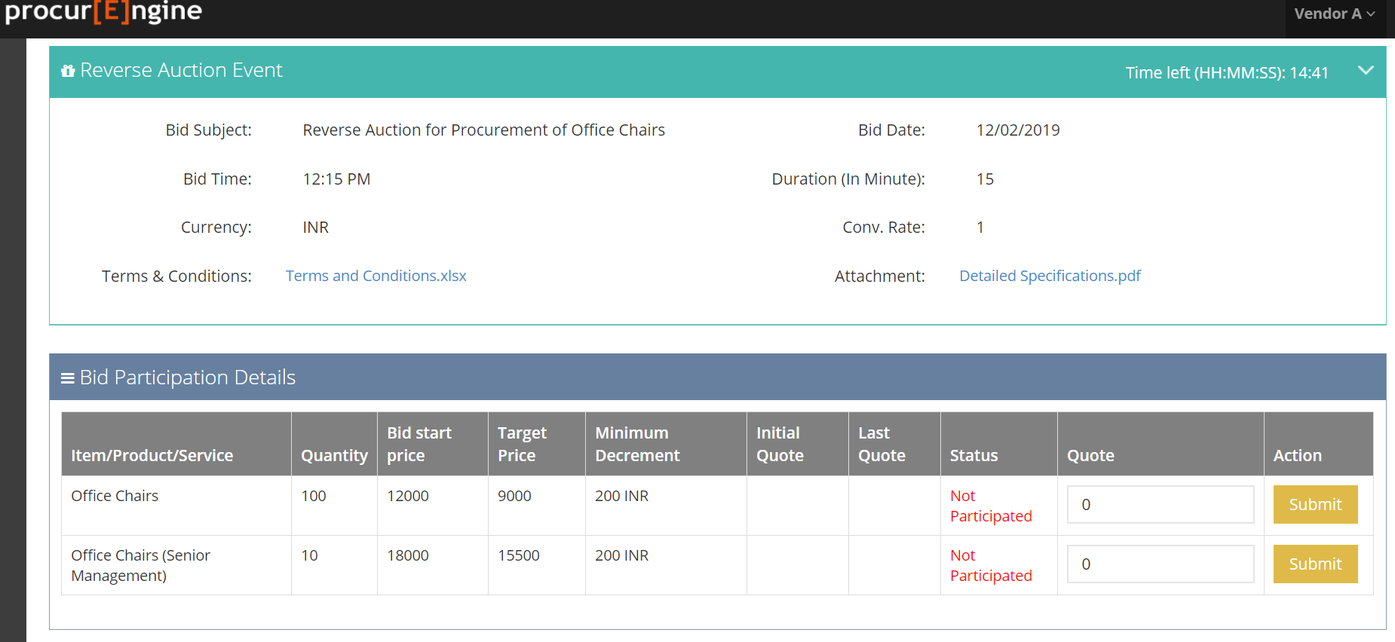

Once you submit your initial price, the dash board will show your ranking in the bid. The rank may change as other bidders start quoting their prices.

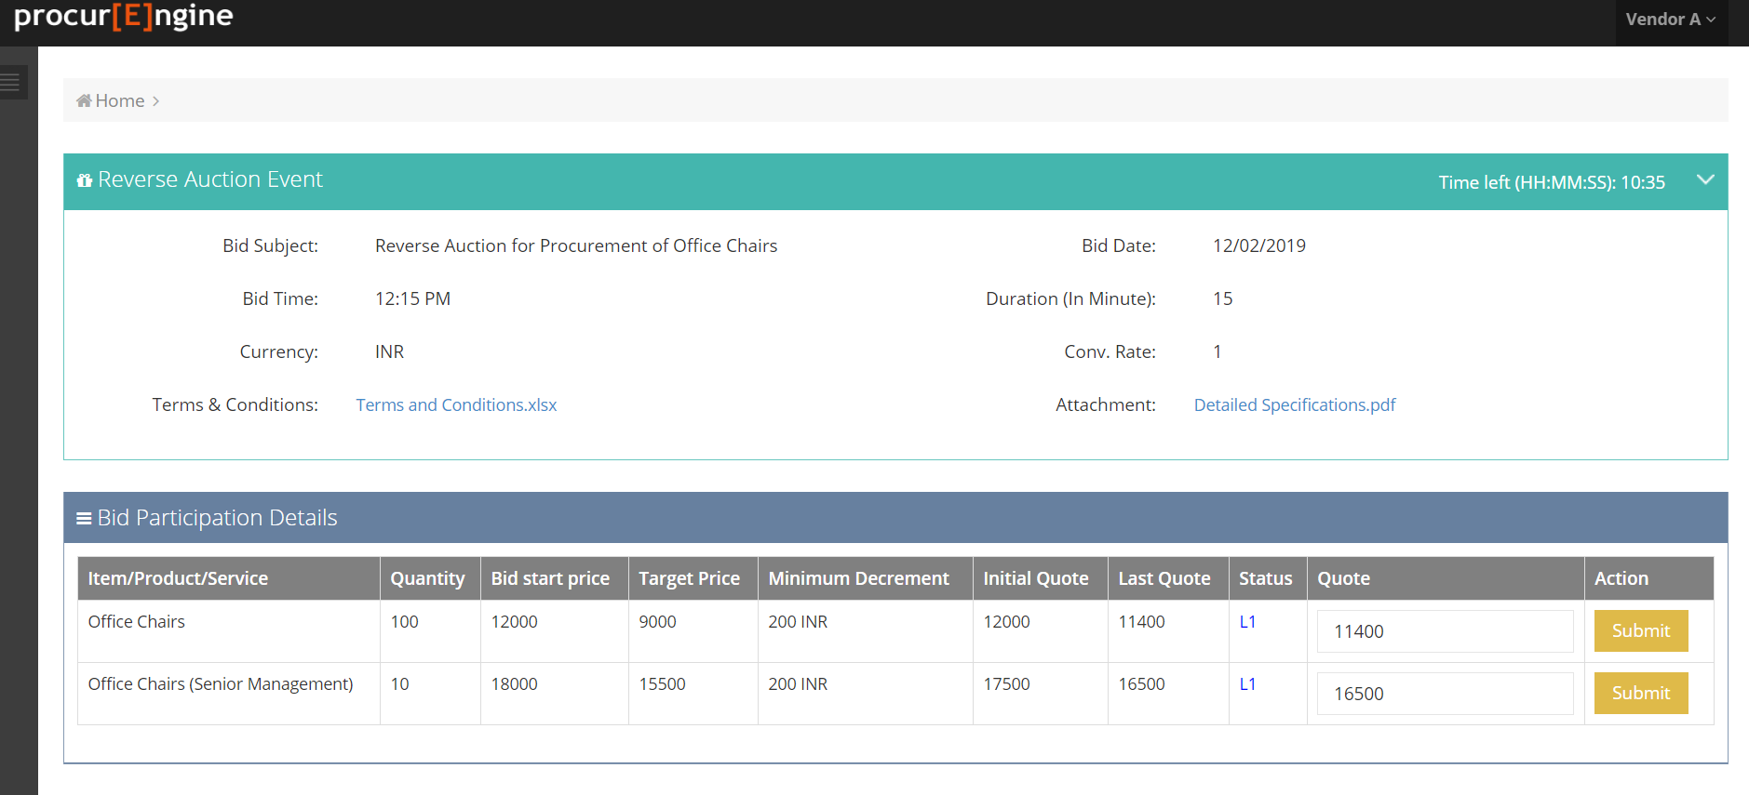

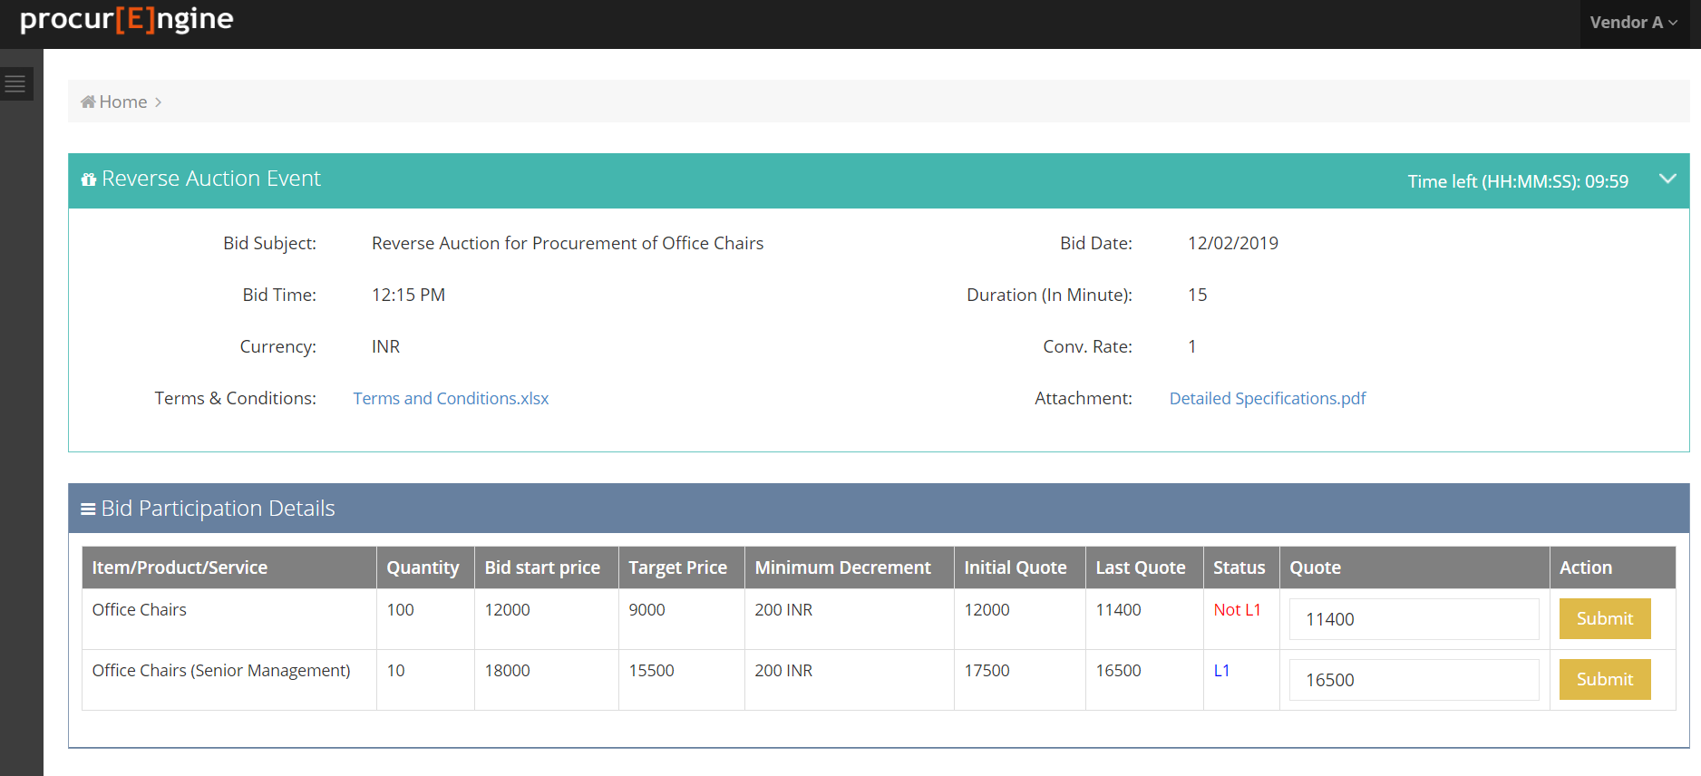

Please Quote price in given text box and click on submit to bid. **If your quote is lowest the status will be shown as "L1"** else "Not L1".

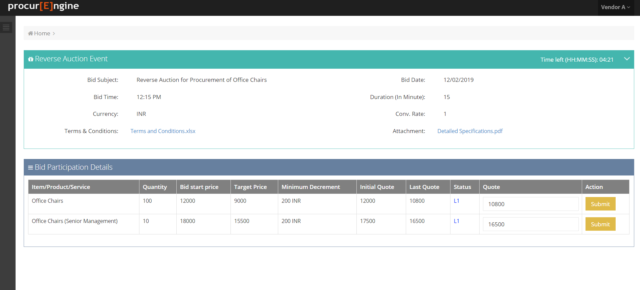

You can reduce your bid in steps. Your next allowed next step should be lower than the current bid by **minimum decrement as indicated in your dash board.** The bid decrement can be price or in percentage. Please do check this carefully at the time of bidding.

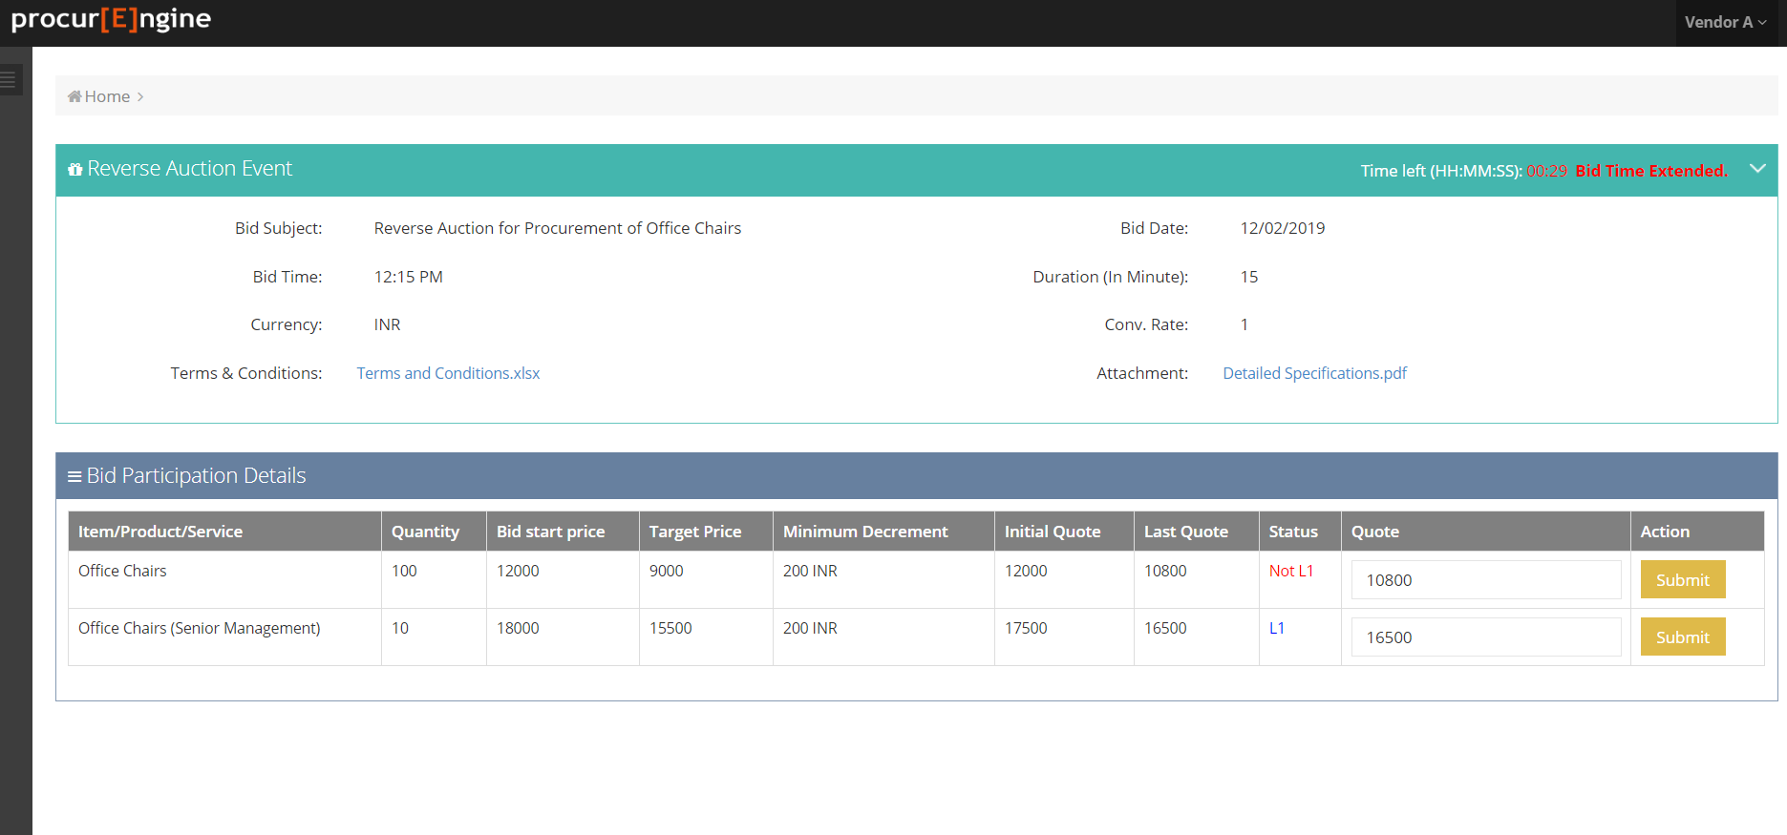

**Step 8:**

Please note that if you quote in last one minute the bid time will automatically get extended by 2 minutes to give fair opportunity to all. Hence avoid quoting your best price at last moment.

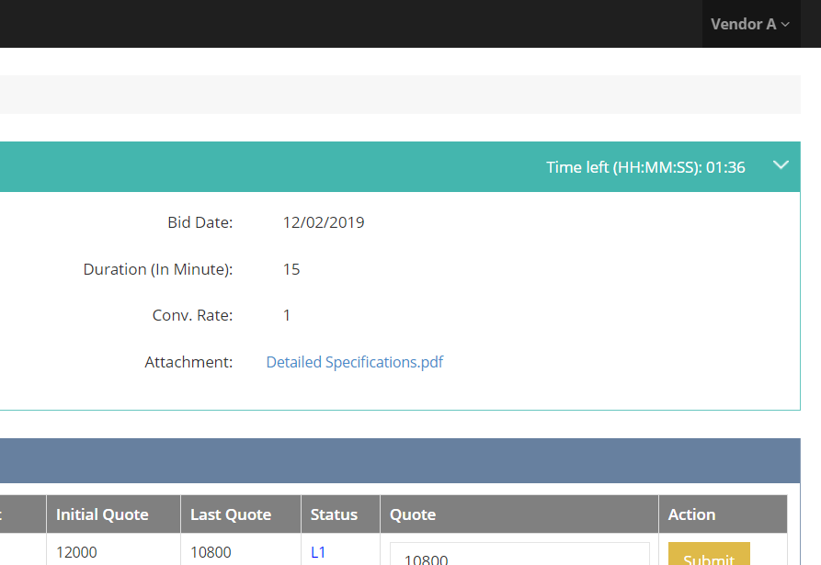

**Step 9:**

Once bid time is over you will be automatically logged off from system. Your customer will contact you for further discussions.

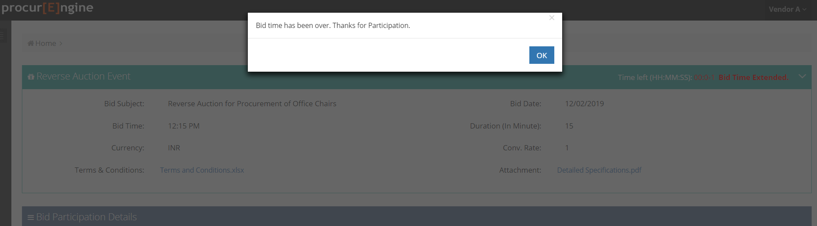

**End of Document**

**Please contact with ProcurEngine Team at**

**+91 844 844 9750 for any assistance**